lab5 Accelerated AI
Q&A:
- Why is Kafka used instead of direct function calls?
  - Kafka buffers events safely in the topic without losing data or crashing the producer.
- What happens if the consumer is slower than the producer?
  - Events accumulate safely in the Kafka topic without blocking or dropping events.
- How does tracing help debug pipeline behavior?
  - It visualizes latency bottlenecks across distributed stages
- Which pipeline stages could be scaled independently?
  - The Consumer_Classifier stage can be scaled up by adding more worker instances to the same Kafka consumer group
- How would this pipeline change in a real SOC system?
  - CSVs are replaced with scalable Kafka runs multi-node clusters, and OpenTelemetry handles massive distributed log ingestion.

Screenshots:
RedPanda:
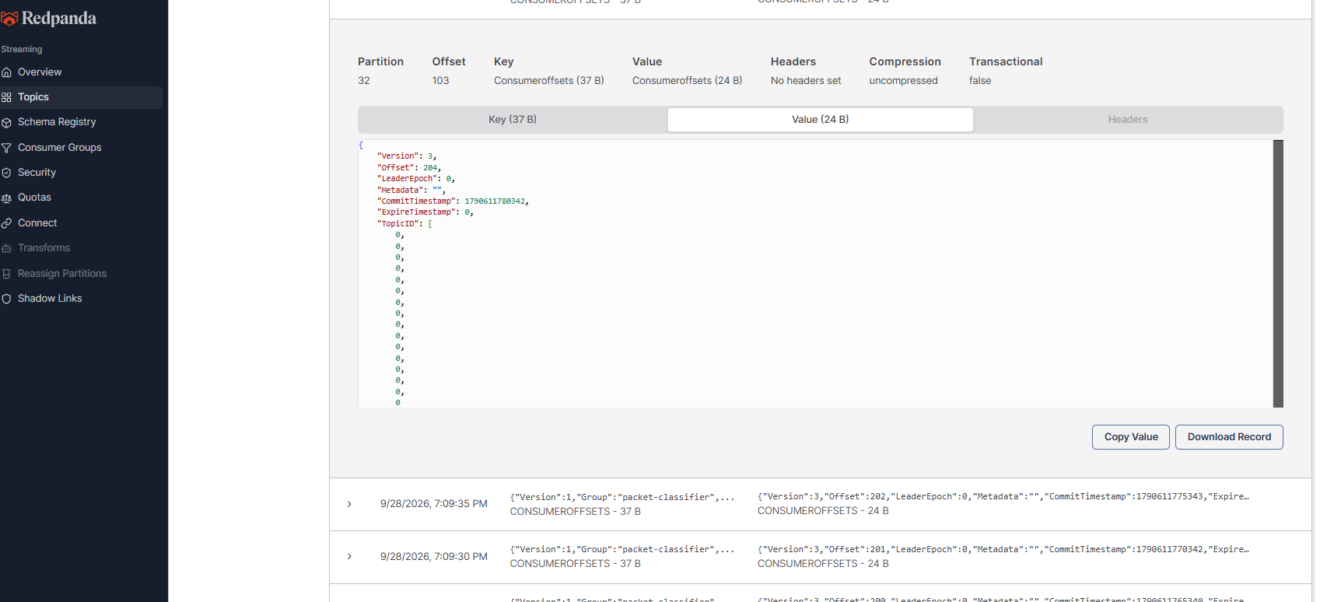

Jaeger:
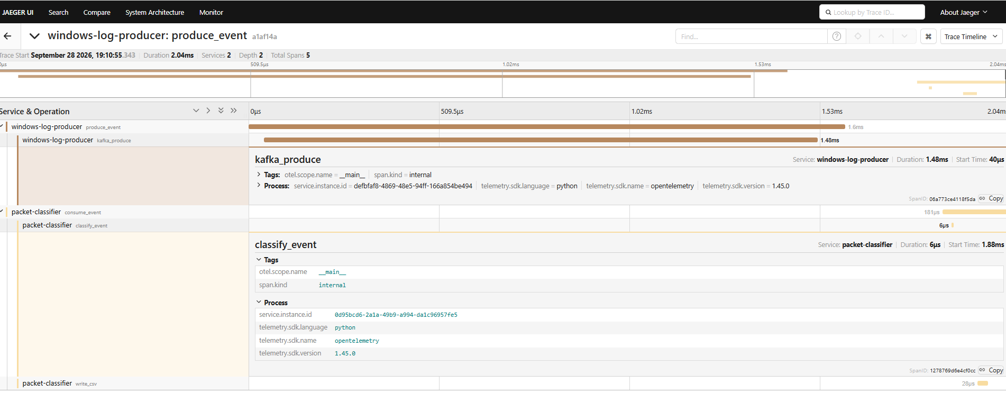
Statistics:
